A Touch Of Gold to DJ Mix

Key Features

2-deck rugged metal DJ controller
- Controls 2 virtual decks + virtual mixer
- Rugged casing in black steel

Impressive DJ controls
- Pressure-detecting jog wheels
- 8 progressive pads
- 2 vu-meters for deck levels

The best of DJ audio standards
- 2 balanced XLR Out for master
- 2 RCA out for booth
- Previewing output: 2 headphones + 2 RCA
- Inputs: 2 stereo inputs

Versatile DJ control
- Mix computer track and external audio
- Controls: scratch on jog, remix on pads
- Audio: balanced out for PA systems, RCA out for monitors, 2 headphones outputs, mic. in, phono/line inputs
Golden Style

Add gold to your visual show
- Appealing gold and black design
- Golden glints on jog wheels and caps
- Golden markings

Fast control
- Tact switches in transport keys => the shortest travel of transport buttons
- True velocity pads = instant trigger
- USB high-speed = fast protocol

Golden audio performance
- Remix your tracks with pads
- Samples play in sync. with the tracks
- You always mix on the beat.
Hercules DJConsole Rmx2 Black-Gold

References / Barcodes
EMEA 4780480 / 3362934744397
USA/ Canada 4769259 / 6 63296 41966 8
UK 4768219 / 3 36293 474450 2

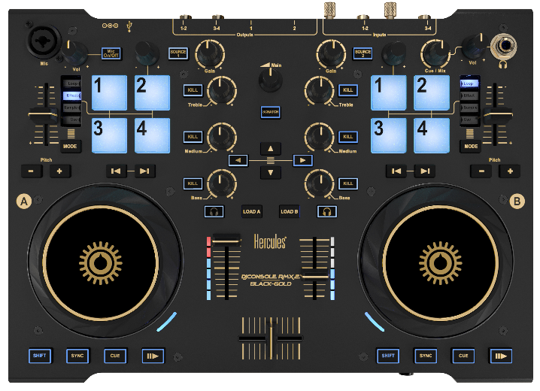
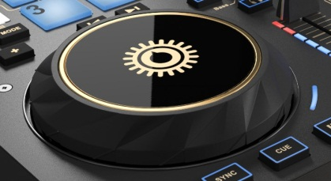
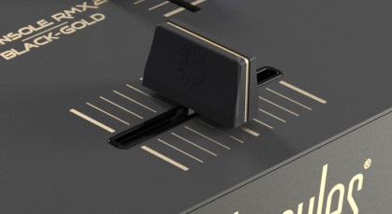
Jog
wheel
Microphone In
Progressive pads
Crossfader Jog wheel Velocity pads XLR outputs
Mechanical specifications
Enclosure 13”78 x 9”85 /35 x 25 cm
Jog wheels 4”72 /12 cm diameter
Weight 4.6 lbs. / 2.1 Kg

Audio specifications
Outputs
1-2 2 x XLR balanced Master
2 x RCA Booth out (line)
3-4 2 x 1/4” stereo jacks for headphones out
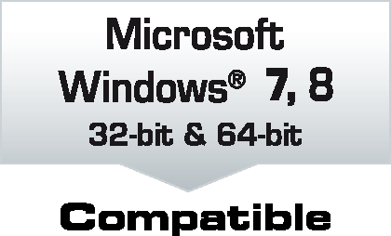
2 x RCA (line level)

Inputs
1-2 2 x RCA (Phono / line)
3-4 2 x RCA (Phono / line)

Mic 1 x XLR/jack balanced microphone in
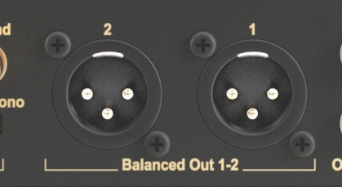
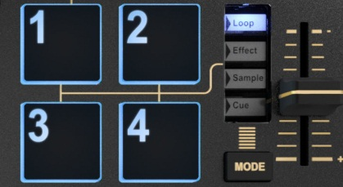
Crossfader
Headphones Out
Rotary
pots
Vu-
meter
VirtualDJ 8 LE
The NEW VIRTUALDJ 8, user-friendly, with
- High-res audio: 24-bit, 44.1, 48 & 96 kHz,
- Synchronized samples: great use of pads,
- Scalable user interface: fit on your display.


DJUCED™ 40°
Juice up your mix, with high-resolution audio.

Recommended system
2 GHz Core 2 Duo / Athlon 64 X2 or faster CPU
2 GB RAM or more
Powered USB port + 100 MB free disk space
1024x768 or higher display resolution
CD/DVD-ROM drive + Internet access
Operating system
Mac OS® 10.7, 10.8, 10.9, 10.10 / MS Windows® 7, 8

